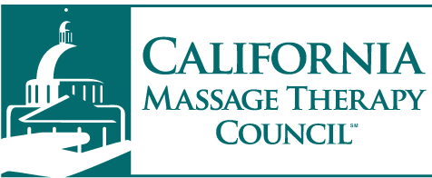

MEDIA ADVISORY Contact:
January 10, 2017 Regina Wilson 951-823-7659

The California Massage Therapy Council Names Legislator of the Year

Sacramento – The California Massage Therapy Council names Assemblymember Rudy Salas (D-Bakersfield) as Legislator of the Year for the 2016 legislative session.

"I am honored to receive this distinguished award and thank the California Massage Therapy Council for this recognition," said Assemblymember Salas (D-Bakersfield). "Together, we were able to craft policy that will protect consumers and enable certified therapists to continue to play a vital healing role in our local communities," said Salas

Salas is recognized for his exemplary leadership and personal engagement as the author of AB 2194, and as Chair of the Assembly Business and Professions Committee. The CAMTC board unanimously selected Salas because of his willingness to carefully work on complex massage regulatory issues, which continue to further define California's leadership in protecting massage consumers and local communities seeking the benefits of therapeutic massage.

"All Californians should be proud of the work done by Assemblymember Salas," said California Massage Therapy Council Chair, Mark Dixon. "Assemblymember Salas’ leadership, personal engagement and command of understanding the issues that impact the safety and quality of life for many Californians is why we've named him Legislator of the Year. We share the same goals and commitment to protecting the public.”

The Legislator of the Year is an award given by the Massage Therapy Council to lawmakers who show exemplary leadership on matters of public importance. Past legislators to receive recognition were former Senators Lou Correa, Curren Price Jr. and former Assemblywoman Susan Bonilla.

##

